FRIENDS AND FAMILY TEST
Results for September 2023

Thank you to all the patients who completed a friends and family test survey in September 2023.

- How likely are you to recommend our practice to family and friends if they needed similar care or treatment?
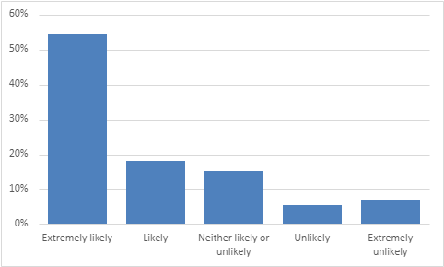

54% are extremely likely to recommend the practice.
18% are likely to recommend the practice.
15% are neither likely nor unlikely to recommend the practice.
5% are unlikely to recommend the practice.
7% are extremely unlikely to recommend the practice.

- If we could change one thing about your care or treatment, what would it be?
- No changes needed. My experience has always been excellent at Acreswood.
- I have always been happy with everything.
- Superb service. We have the best Practice.
- Polite and helpful staff. Excellent care from all staff even when under pressure.
- Reception staff friendly and helpful.
- I found Dr Harris to be very compassionate and holistic.
- Dr Hart is very approachable.
- Good service – possible to get appointments at short notice if really needed.
- Have easy online booking for appointments.
- Publish a monthly report on health issues, other news items and inform patients of best practice.
- To cut waiting times, have more appointments available for people who work unsociable hours and to have more face to face appointments.
- Reinstating the ear wax removal service.
- Improve the phone system. Can be very difficult to get through.
- Sometimes find reception staff unhelpful.

